Bounty Hacker VM Walkthrough
By
David Ketterman (K1t5un3)
Recon
First run Nmap to determine open service ports. Please keep in mind the IP address changes every time it is deployed.
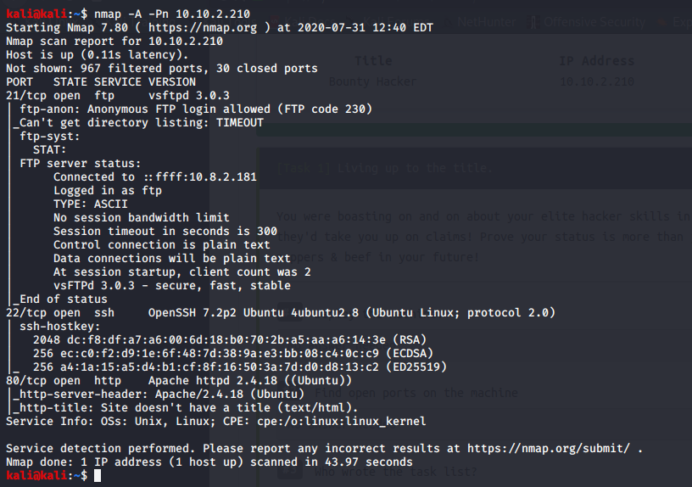
From here we can determine TCP ports 21,22, and 80 are open and are the default ports for FTP, SSH, and HTTP. FTP has Anonymous login enabled which allows us read only access. Given this information we log in to find 2 files, locks.txt and task.txt.
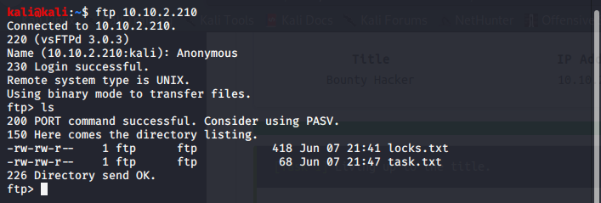
The file “locks.txt” looks like a password list which can be used to brute force the SSH server. However, we need a username to test. Checking the file “task.txt” shows a possible username lin.
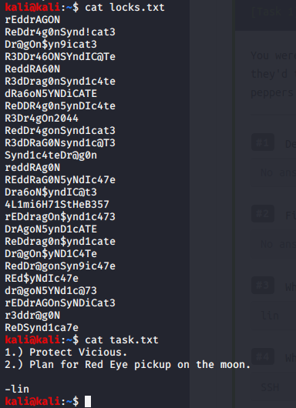
System Hacking
We then use Hydra to brute force the SSH login to determine the password. After the session is complete the password has been found for the user lin.
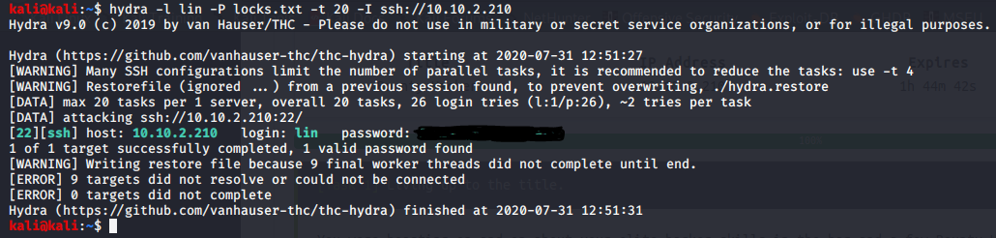
Login using SSH to access Lin’s account. We should have access to the “user.txt” file and access to its contents.
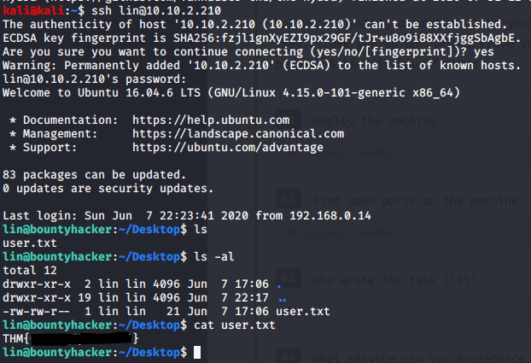

Recon for Privilege Escalation
We now need to gain access to the root account. First let’s check to see if Lin has access to the sudo command by using “sudo -l”. This command lists out all programs that can use sudo. Given the password we can use sudo on the tar command.
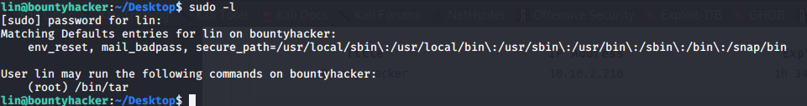
Privilege Escalation
The tar command is a common Linux program therefore we should check the website GTFObin for privilege escalation commands. The command to allow privilege escalation using the sudo command is found in https://gtfobins.github.io/gtfobins/tar/#sudo. Using the command “sudo tar -cf /dev/null /dev/null --checkpoint=1 --checkpoint-action=exec=/bin/sh” we gain access to the root account and the root.txt file.
